**Project Report**

**Title****: Movie Booking System**

## BACHELOR OF TECHNOLOGY

Computer science and Engineering

Submitted to

## Mr Mir Salim

**LOVELY PROFESSIONAL UNIVERSITY PHAGWARA, PUNJAB**

**SUBMITTED BY :- Praveen Kumar(12222139), Priyanshu Sahay(12222301),**

**M. Chandini(12222546)**

**ACKNOWLEDGEMENT**

First and foremost, we would like to express our gratitude to our Faculty, Mr. Mir Salim who was a continual source of inspiration. He pushed us to think imaginatively and urged us to do this homework without hesitation. His vast knowledge, extensive experience, and professional competence in HTML and CSS enabled us to successfully accomplish this project. This endeavor would not have been possible without his help and supervision. We could not have asked for a finer mentor in our studies. This initiative would not have been a success without the contributions of each and every individual. We were always there to cheer each other on, and that is what kept us together until the end.

I’d like to thank The LPU for providing us with the opportunity to work on the project(**Movie Booking System**). Last but not least, I would like to express my gratitude to my family, siblings, and friends for their invaluable assistance, and I am deeply grateful to everyone who has contributed to the successful completion of this project

**Code Snapshot**

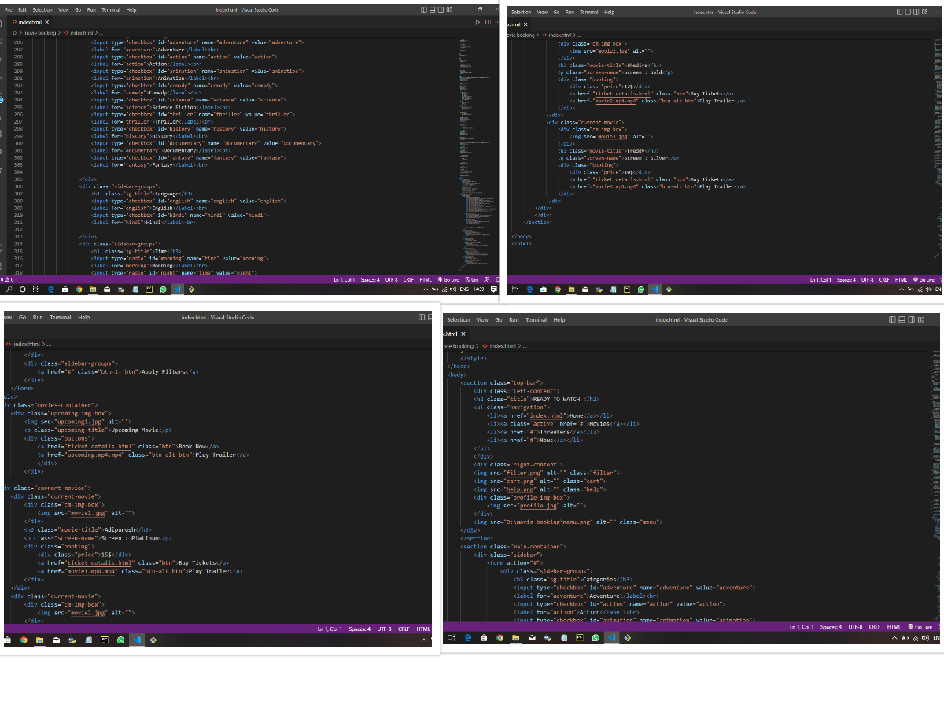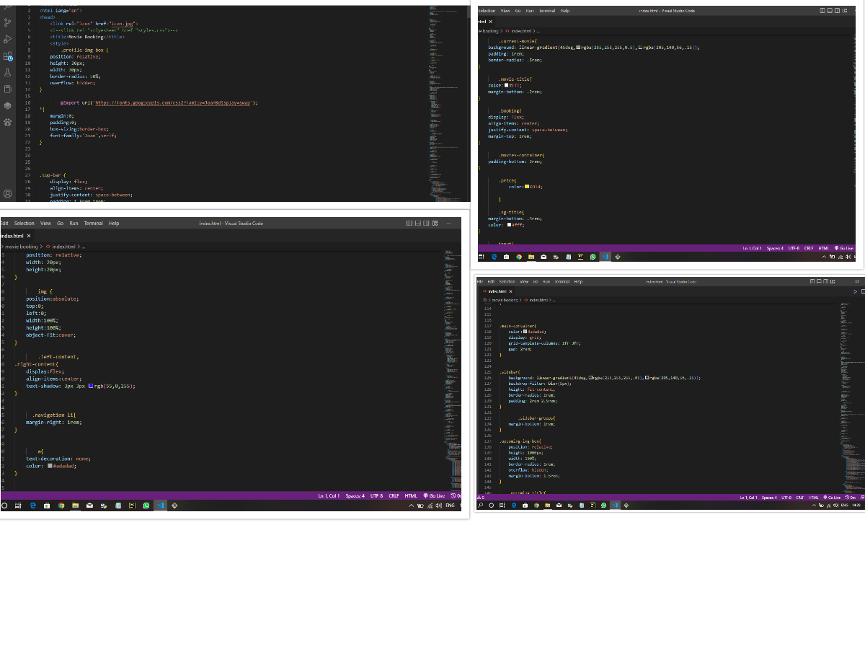

Final Output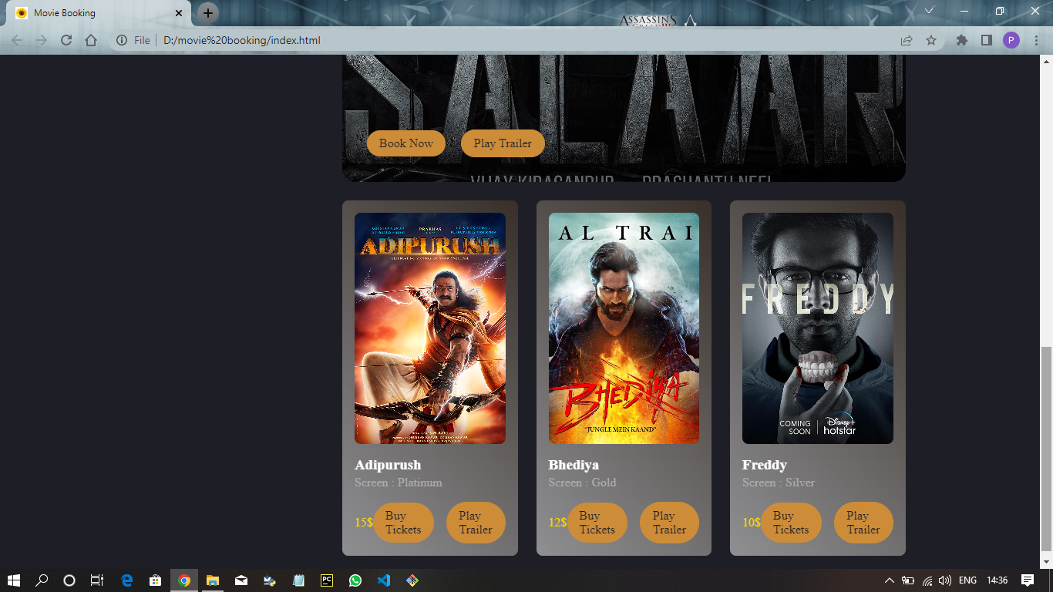

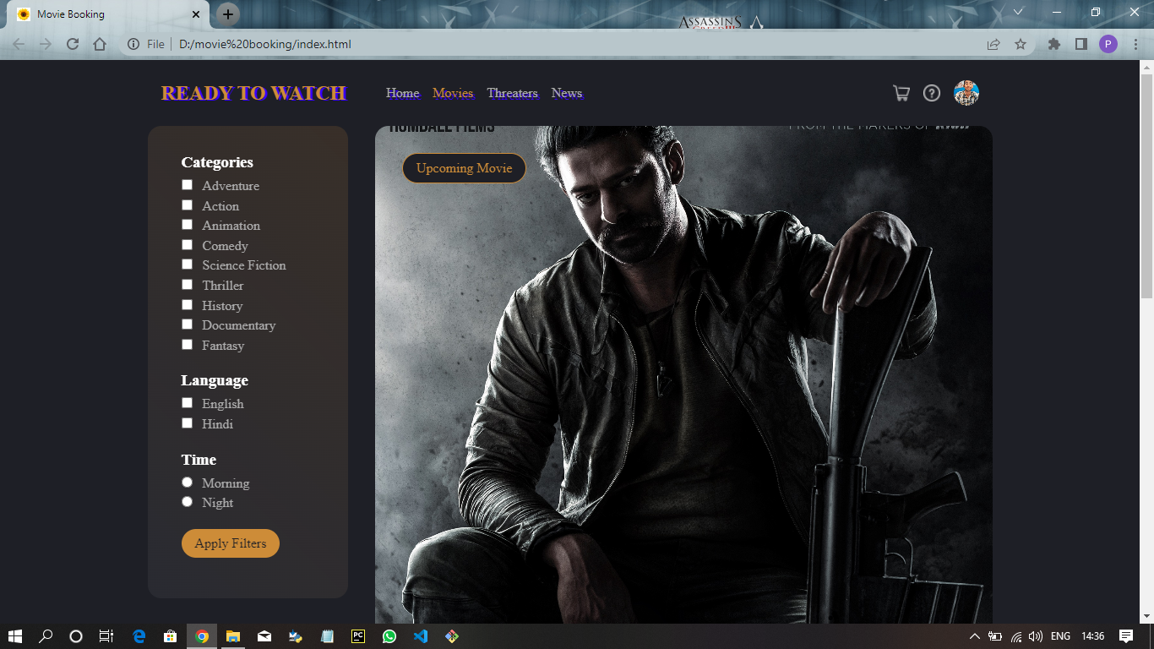

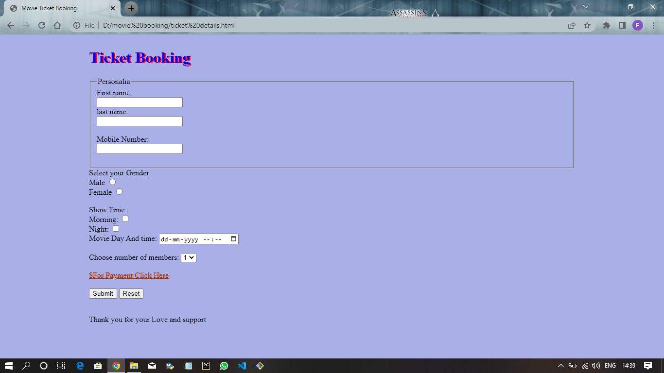

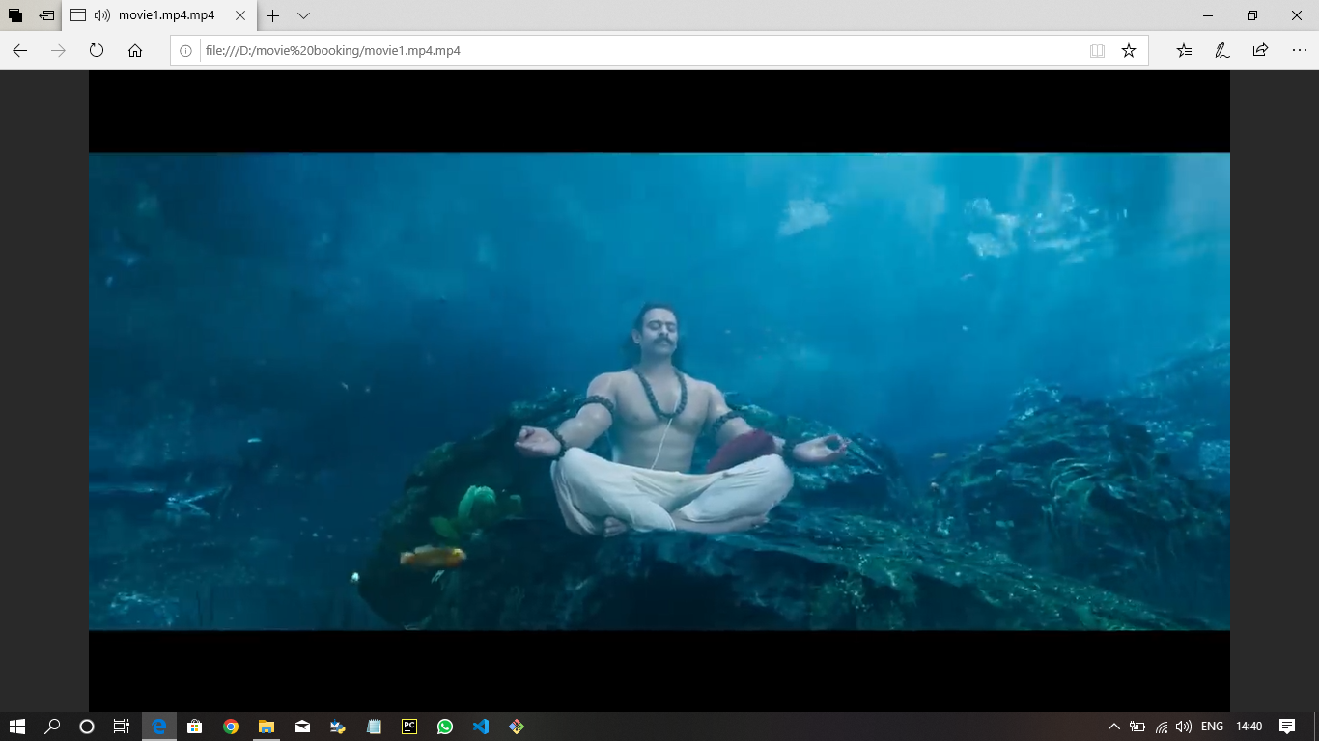

## Conclusion

Our project “Movie Booking System”

is based on that you can book tickets

of upcoming movies and watch the trailer of upcoming movies .And name of the webpage Is Ready TO Watch . one can book ticket on affordable price and it is full secure and enjoyable .And easily reachable

Thank Youo